**DEPARTMENT OF COMPUTER SCIENCE**

**RAJAGIRI COLLEGE OF SOCIAL SCIENCES**

**(Autonomous)**

**KALAMASSERY - KOCHI - 683104**



MASTER OF COMPUTER APPLICATIONS

**WEB TECHNOLOGY LAB**

**MCA 206**

**LAB RECORD**

**NAME                    : Arjun Vijay**

**SEMESTER          :  II**

**REGISTER NO   :**

#### https://lh6.googleusercontent.com/2EPKvjGk7IDraYhnb3peVwxDH_yyfV-ZlLIvCeK4bU3oD_ok1r6OCqBxaivOlmRsO85OsQen_06dCae9CJ4gHyfj6yaYXQN2kvy5SAHNdw9HqF9eAQFtJZYShdiZiQ

#### DEPARTMENT OF COMPUTER SCIENCE

#### RAJAGIRI COLLEGE OF SOCIAL SCIENCES

#### (Autonomous)

**KALAMASSERY - KOCHI – 683104**

### MASTER OF COMPUTER APPLICATIONS

###### **CERTIFICATE**

**NAME                     :  Arjun Vijay**

**SEMESTER           : II**

**REGISTER NO     :**

*Certified that this is a bonafide record of work done by the student in the Software Laboratory of Rajagiri Department of Computer Science, Kalamassery.*

Mr. Diljith K Benny Dr. Bindiya M Varghese

Faculty in Charge Dean, Computer Science

Internal Examiner             External Examiner

Place   : Kalamassery

Date    : 

**Table of Contents           Page No**

|  |  |
| --- | --- |
| 1. Program to create a 3D boxes background |  |
| 2. Program to create an Animated countdown. |  |
| 3. Program to create a Todo list App. |  |
| 4. Program to create an Auto Text Effect. |  |
| 5. Program to create a Background Slider App. |  |
| 6. Program to create a Blurry loading App. |  |
| 7. Program to create a Button Ripple Effect. |  |
| 8. Program to create a Content place holder. |  |
| 9. Program to create a Custom-Range slider. |  |
| 10. Program to create a Project Starter. |  |
| 11. XML Program to create a user registration page. |  |
| 12. XML program to print details of a breakfast menu. |  |
| 13. XML program to print details of a books. |  |
| 14. AJAX Program to retrieve data from a Txt. |  |
| 15. AJAX Program to retrieve all header information of a file. |  |
| 16. AJAX Program to retrieve all specific information of a file. |  |
| 17. Reversing a string using php code. |  |
| 18. Swapping two numbers. |  |
| 19. Finding the Area of a rectangle using PHP. |  |
| 20. Displaying the current date |  |
| 21. Implementing palindrome using php. |  |
| 22. Extracting number from string. |  |
| 23. Implementing Exception handling |  |
| 24. Create a form using PHP |  |
| 25. Check whether the number is prime or not |  |
| 26. Multiples of seven implemented using PHP |  |
| 27. Program to display email details using JSON |  |
| 28. Program to details of a breakfast menu using JSON |  |
| 29. Program to display details of books using JSON |  |

|  |
| --- |
| **PROGRAM #1 03-02-2022** |
| Program to create a 3D Boxes background. |

<!DOCTYPE html>

<html lang="en">

<head>

<meta charset="UTF-8" />

<meta name="viewport" content="width=device-width, initial-scale=1.0" />

<link

rel="stylesheet"

href="https://cdnjs.cloudflare.com/ajax/libs/font-awesome/5.14.0/css/all.min.css"

integrity="sha512-1PKOgIY59xJ8Co8+NE6FZ+LOAZKjy+KY8iq0G4B3CyeY6wYHN3yt9PW0XpSriVlkMXe40PTKnXrLnZ9+fkDaog=="

crossorigin="anonymous"

/>

<link rel="stylesheet" href="style.css" />

<title>3D Boxes Background</title>

</head>

<body>

<button id="btn" class="magic">Magic 🎩</button>

<div id="boxes" class="boxes big"></div>

<script src="script.js"></script>

</body>

</html>

**Java Script code**-

const boxesContainer = document.getElementById('boxes')

const btn = document.getElementById('btn')

btn.addEventListener('click', () => boxesContainer.classList.toggle('big'))

function createBoxes() {

for (let i = 0; i < 4; i++) {

for (let j = 0; j < 4; j++) {

const box = document.createElement('div')

box.classList.add('box')

box.style.backgroundPosition = `${-j * 125}px ${-i * 125}px`

boxesContainer.appendChild(box)

}

}

}

createBoxes()

**CSS code-**

@import url('https://fonts.googleapis.com/css2?family=Roboto:wght@400;700&display=swap');

@import url('https://fonts.googleapis.com/css2?family=Poppins&display=swap');

* {

box-sizing: border-box;

}

body {

background-color: #fafafa;

font-family: 'Roboto', sans-serif;

display: flex;

flex-direction: column;

align-items: center;

justify-content: center;

height: 100vh;

overflow: hidden;

}

.magic {

background-color: #f9ca24;

color: #fff;

font-family: 'Poppins', sans-serif;

border: 0;

border-radius: 3px;

font-size: 16px;

padding: 12px 20px;

cursor: pointer;

position: fixed;

top: 20px;

letter-spacing: 1px;

box-shadow: 0 3px rgba(249, 202, 36, 0.5);

z-index: 100;

}

.magic:focus {

outline: none;

}

.magic:active {

box-shadow: none;

transform: translateY(2px);

}

.boxes {

display: flex;

flex-wrap: wrap;

justify-content: space-around;

height: 500px;

width: 500px;

position: relative;

transition: 0.4s ease;

}

.boxes.big {

width: 600px;

height: 600px;

}

.boxes.big .box {

transform: rotateZ(360deg);

}

.box {

background-image: url('https://media.giphy.com/media/EZqwsBSPlvSda/giphy.gif');

background-repeat: no-repeat;

background-size: 500px 500px;

position: relative;

height: 125px;

width: 125px;

transition: 0.4s ease;

}

.box::after {

content: '';

background-color: #f6e58d;

position: absolute;

top: 8px;

right: -15px;

height: 100%;

width: 15px;

transform: skewY(45deg);

}

.box::before {

content: '';

background-color: #f9ca24;

position: absolute;

bottom: -15px;

left: 8px;

height: 15px;

width: 100%;

transform: skewX(45deg);

}

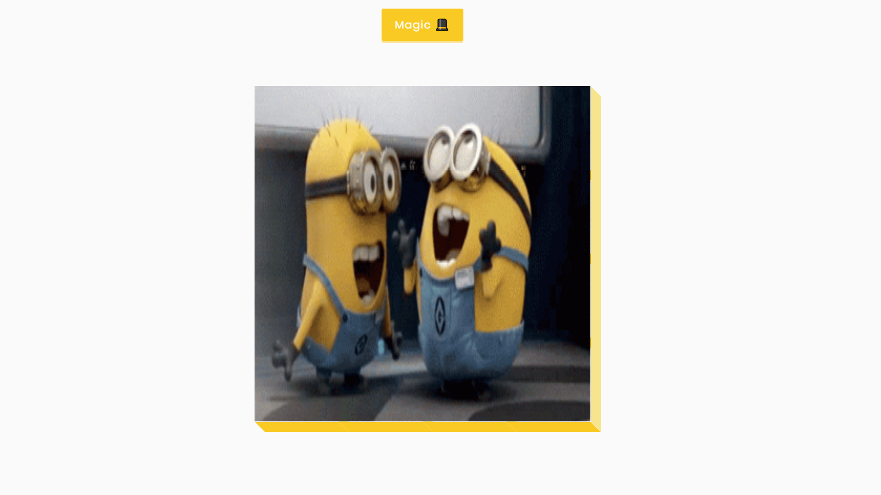

|  |
| --- |
| **PROGRAM #2 03-02-2022** |
| Program to create an animated countdown. |

<!DOCTYPE html>

<html lang="en">

<head>

<meta charset="UTF-8" />

<meta name="viewport" content="width=device-width, initial-scale=1.0" />

<link rel="stylesheet" href="style.css" />

<title>Animated Countdown</title>

</head>

<body>

<div class="counter">

<div class="nums">

<span class="in">3</span>

<span>2</span>

<span>1</span>

<span>0</span>

</div>

<h4>Get Ready</h4>

</div>

<div class="final">

<h1>GO</h1>

<button id="replay">

<span>Replay</span>

</button>

</div>

<script src="script.js"></script>

</body>

</html>

**JavaScript code-**

const nums = document.querySelectorAll('.nums span')

const counter = document.querySelector('.counter')

const finalMessage = document.querySelector('.final')

const replay = document.querySelector('#replay')

runAnimation()

function resetDOM() {

counter.classList.remove('hide')

finalMessage.classList.remove('show')

nums.forEach((num) => {

num.classList.value = ''

})

nums[0].classList.add('in')

}

function runAnimation() {

nums.forEach((num, idx) => {

const nextToLast = nums.length - 1

num.addEventListener('animationend', (e) => {

if (e.animationName === 'goIn' && idx !== nextToLast) {

num.classList.remove('in')

num.classList.add('out')

} else if (e.animationName === 'goOut' && num.nextElementSibling) {

num.nextElementSibling.classList.add('in')

} else {

counter.classList.add('hide')

finalMessage.classList.add('show')

}

})

})

}

replay.addEventListener('click', () => {

resetDOM()

runAnimation()

})

**CSS code-**

@import url('https://fonts.googleapis.com/css2?family=Roboto:wght@400;700&display=swap');

* {

box-sizing: border-box;

}

body {

font-family: 'Roboto', sans-serif;

margin: 0;

height: 100vh;

overflow: hidden;

}

h4 {

font-size: 20px;

margin: 5px;

text-transform: uppercase;

}

.counter {

position: fixed;

top: 50%;

left: 50%;

transform: translate(-50%, -50%);

text-align: center;

}

.counter.hide {

transform: translate(-50%, -50%) scale(0);

animation: hide 0.2s ease-out;

}

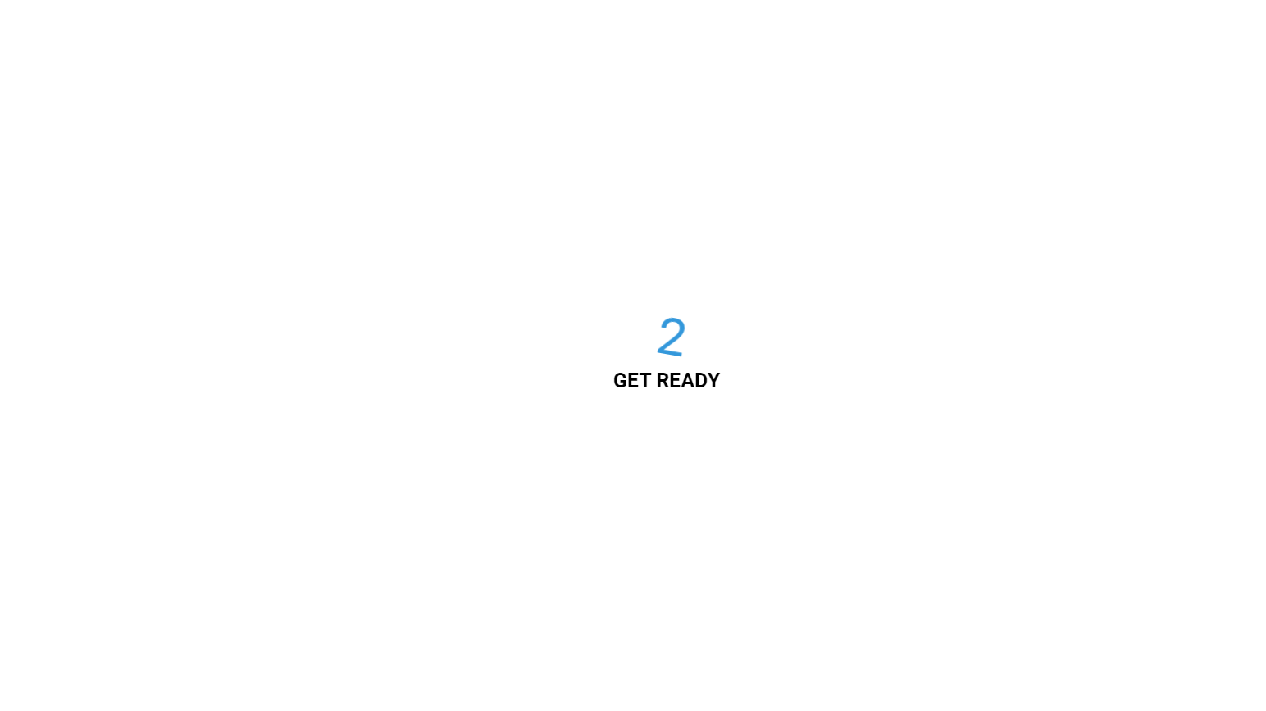

|  |
| --- |
| **PROGRAM #3 03-02-2022** |
| Program to create a Todo list App. |

<!DOCTYPE html>

<html lang="en">

<head>

<meta charset="utf-8">

<meta name="viewport" content="width=device-width, initial-scale=1.0, user-scalable=yes">

<link rel="stylesheet" type="text/css" href="mystyle.css">

</head>

<body>

<div id ="wrapper">

<h1> Todo List</h1>

<input id="task" ><button id="add">Add Task</button>

<!--<hr>-->

<div id="todos"></div>

</div>

<script src="myscript.js"></script>

</body>

</html>

**JavaScript code-**

function get_todos(){

var todos = new Array;

var todos_str = localStorage.getItem('todo');

if (todos_str !== null) {

todos =JSON.parse(todos_str);

}

return todos;

}

function add(){

var task = document.getElementById('task').value;

var todos =get_todos();

todos.push(task);

localStorage.setItem('todo', JSON.stringify(todos));

show();

return false;

}

function clearDefault(a){

if (a.defaultValue==a.value) {a.value=""}

};

function remove(){

var id = this.getAttribute('id');

var todos = get_todos();

todos.splice(id,1);

localStorage.setItem('todo',JSON.stringify(todos));

show();

return false;

}

function show(){

var todos = get_todos();

var html = '<ul>';

for(var i=0; i<todos.length; i++){

html += '<li>' + todos[i] + '<button class="remove" id="' + i + '">Delete</button> </li>';

};

html += '</ul>';

document.getElementById('todos').innerHTML = html;

var buttons = document.getElementsByClassName('remove');

for(var i=0; i< buttons.length; i++){

buttons[i].addEventListener('click',remove);

};

}

document.getElementById('add').addEventListener('click', add);

show();

**CSS code-**

body {

text-align: center;

/*background-color: #3c6dc5;*/

background-color: #6495ed;

color: white;

font-family: helvetica,Arial;

background-image: url(wp5807902-life-goes-on-wallpapers.jpg);

background-attachment: fixed;

background-size: 2000px;

background-repeat: no-repeat;

}

#add

{

background-color: red;

border: 0;

color: white;

padding: 10px 10px;

padding-right: 30px;

cursor: pointer;

margin-top: 35px;

}

.remove{

margin-top: 13px;

background-color: #ffcdcd;

float:right;

clear:both;

padding-right: 20px;

border-radius: 5px;

width:60px;

height: 20px;

border-style: none;

}

#wrapper{

margin-left: 472px;

width:450px;

background-color: #535457;

margin-top: 120px;

/* margin-left:295px; */

padding-bottom: 30px;

padding-left: 50px;

padding-top: 30px;

padding-right: 45px;

border-radius:25px;

}

ul{

list-style: none;

text-align: left;

line-height: 35px;

}

#task{

width:320px;

height: 30px;

margin-left: 17px;

}

h1{

margin-top: 30px;

}

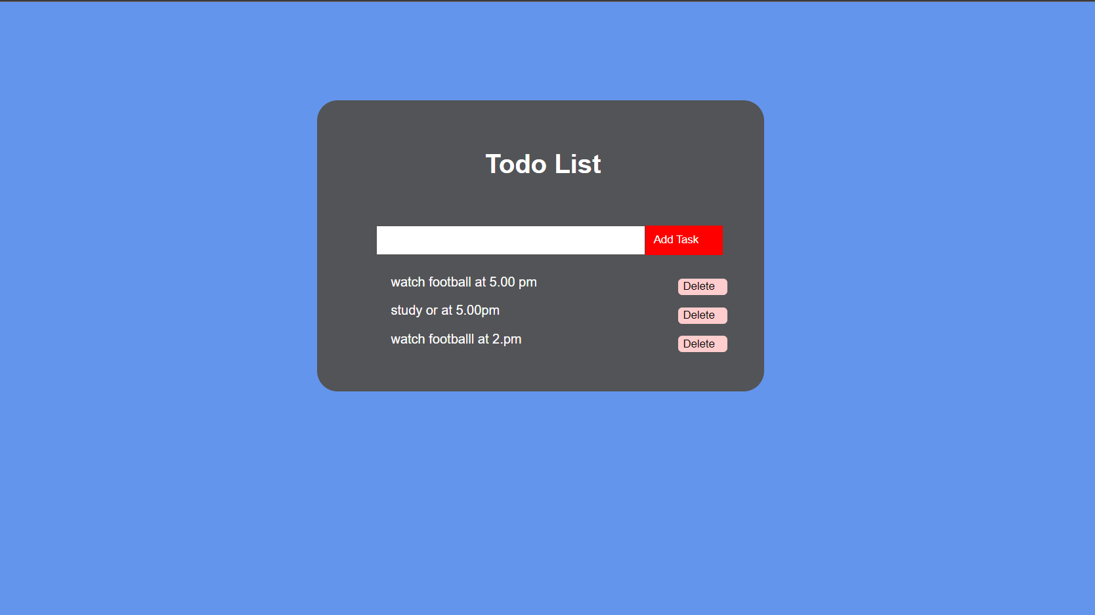

|  |
| --- |
| **PROGRAM #4 03-02-2022** |
| Program to create an Auto Text Effect. |

<!DOCTYPE html>

<html lang="en">

<head>

<meta charset="UTF-8" />

<meta name="viewport" content="width=device-width, initial-scale=1.0" />

<link rel="stylesheet" href="style.css" />

<title>Auto Text Effect</title>

</head>

<body>

<h1 id="text">Starting...</h1>

<div>

<label for="speed">Speed:</label>

<input type="number" name="speed" id="speed" value="1" min="1" max="10" step="1">

</div>

<script src="script.js"></script>

</body>

</html>

**JavaScript code-**

const textEl = document.getElementById('text')

const speedEl = document.getElementById('speed')

const text = 'We Love Programming!'

let idx = 1

let speed = 300 / speedEl.value

writeText()

function writeText() {

textEl.innerText = text.slice(0, idx)

idx++

if(idx > text.length) {

idx = 1

}

setTimeout(writeText, speed)

}

speedEl.addEventListener('input', (e) => speed = 300 / e.target.value)

**CSS code-**

@import url('https://fonts.googleapis.com/css2?family=Roboto:wght@400;700&display=swap');

* {

box-sizing: border-box;

}

body {

background-color: darksalmon;

font-family: 'Roboto', sans-serif;

display: flex;

flex-direction: column;

align-items: center;

justify-content: center;

height: 100vh;

overflow: hidden;

margin: 0;

}

div {

position: absolute;

bottom: 20px;

background: rgba(0, 0, 0, 0.1);

padding: 10px 20px;

font-size: 18px;

}

input {

width: 50px;

padding: 5px;

font-size: 18px;

background-color: darksalmon;

border: none;

text-align: center;

}

input:focus {

outline: none;

}

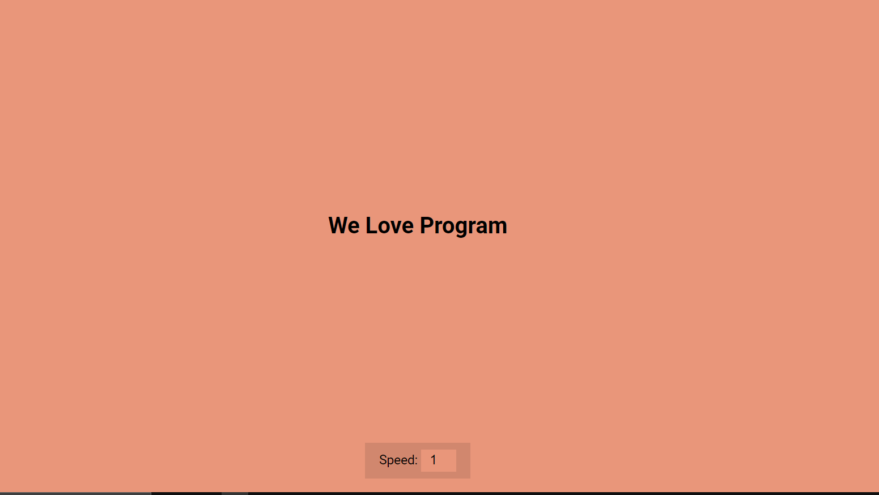

|  |
| --- |
| **PROGRAM #5 03-02-2022** |
| Program to create a Background Slider App. |

<!DOCTYPE html>

<html lang="en">

<head>

<meta charset="UTF-8" />

<meta name="viewport" content="width=device-width, initial-scale=1.0" />

<link

rel="stylesheet"

href="https://cdnjs.cloudflare.com/ajax/libs/font-awesome/5.14.0/css/all.min.css"

integrity="sha512-1PKOgIY59xJ8Co8+NE6FZ+LOAZKjy+KY8iq0G4B3CyeY6wYHN3yt9PW0XpSriVlkMXe40PTKnXrLnZ9+fkDaog=="

crossorigin="anonymous"

/>

<link rel="stylesheet" href="style.css" />

<title>Background Slider</title>

</head>

<body>

<div class="slider-container">

<div

class="slide active"

style="

background-image: url('https://images.unsplash.com/photo-1549880338-65ddcdfd017b?ixlib=rb-1.2.1&ixid=eyJhcHBfaWQiOjEyMDd9&auto=format&fit=crop&w=2100&q=80');

"

></div>

<div

class="slide"

style="

background-image: url('https://images.unsplash.com/photo-1511593358241-7eea1f3c84e5?ixlib=rb-1.2.1&ixid=eyJhcHBfaWQiOjEyMDd9&auto=format&fit=crop&w=1934&q=80');

"

></div>

<div

class="slide"

style="

background-image: url('https://images.unsplash.com/photo-1495467033336-2effd8753d51?ixlib=rb-1.2.1&ixid=eyJhcHBfaWQiOjEyMDd9&auto=format&fit=crop&w=2100&q=80');

"

></div>

<div

class="slide"

style="

background-image: url('https://images.unsplash.com/photo-1522735338363-cc7313be0ae0?ixlib=rb-1.2.1&ixid=eyJhcHBfaWQiOjEyMDd9&auto=format&fit=crop&w=2689&q=80');

"

></div>

<div

class="slide"

style="

background-image: url('https://images.unsplash.com/photo-1559087867-ce4c91325525?ixlib=rb-1.2.1&ixid=eyJhcHBfaWQiOjEyMDd9&auto=format&fit=crop&w=2100&q=80');

"

></div>

<button class="arrow left-arrow" id="left">

<i class="fas fa-arrow-left"></i>

</button>

<button class="arrow right-arrow" id="right">

<i class="fas fa-arrow-right"></i>

</button>

</div>

<script src="script.js"></script>

</body>

</html>

**JavaScript code-**

const body = document.body

const slides = document.querySelectorAll('.slide')

const leftBtn = document.getElementById('left')

const rightBtn = document.getElementById('right')

let activeSlide = 0

rightBtn.addEventListener('click', () => {

activeSlide++

if (activeSlide > slides.length - 1) {

activeSlide = 0

}

setBgToBody()

setActiveSlide()

})

leftBtn.addEventListener('click', () => {

activeSlide--

if (activeSlide < 0) {

activeSlide = slides.length - 1

}

setBgToBody()

setActiveSlide()

})

setBgToBody()

function setBgToBody() {

body.style.backgroundImage = slides[activeSlide].style.backgroundImage

}

function setActiveSlide() {

slides.forEach((slide) => slide.classList.remove('active'))

slides[activeSlide].classList.add('active')

}

**CSS code-**

@import url('https://fonts.googleapis.com/css2?family=Roboto:wght@400;700&display=swap');

* {

box-sizing: border-box;

}

body {

font-family: 'Roboto', sans-serif;

display: flex;

flex-direction: column;

align-items: center;

justify-content: center;

height: 100vh;

overflow: hidden;

margin: 0;

background-position: center center;

background-size: cover;

transition: 0.4s;

}

body::before {

content: '';

position: absolute;

top: 0;

left: 0;

width: 100%;

height: 100vh;

background-color: rgba(0, 0, 0, 0.7);

z-index: -1;

}

.slider-container {

box-shadow: 0 3px 6px rgba(0, 0, 0, 0.16), 0 3px 6px rgba(0, 0, 0, 0.23);

height: 70vh;

width: 70vw;

position: relative;

overflow: hidden;

}

.slide {

opacity: 0;

height: 100vh;

width: 100vw;

background-position: center center;

background-size: cover;

position: absolute;

top: -15vh;

left: -15vw;

transition: 0.4s ease;

z-index: 1;

}

.slide.active {

opacity: 1;

}

.arrow {

position: fixed;

background-color: transparent;

color: #fff;

padding: 20px;

font-size: 30px;

border: 2px solid orange;

top: 50%;

transform: translateY(-50%);

cursor: pointer;

}

.arrow:focus {

outline: 0;

}

.left-arrow {

left: calc(15vw - 65px);

}

.right-arrow {

right: calc(15vw - 65px);

}

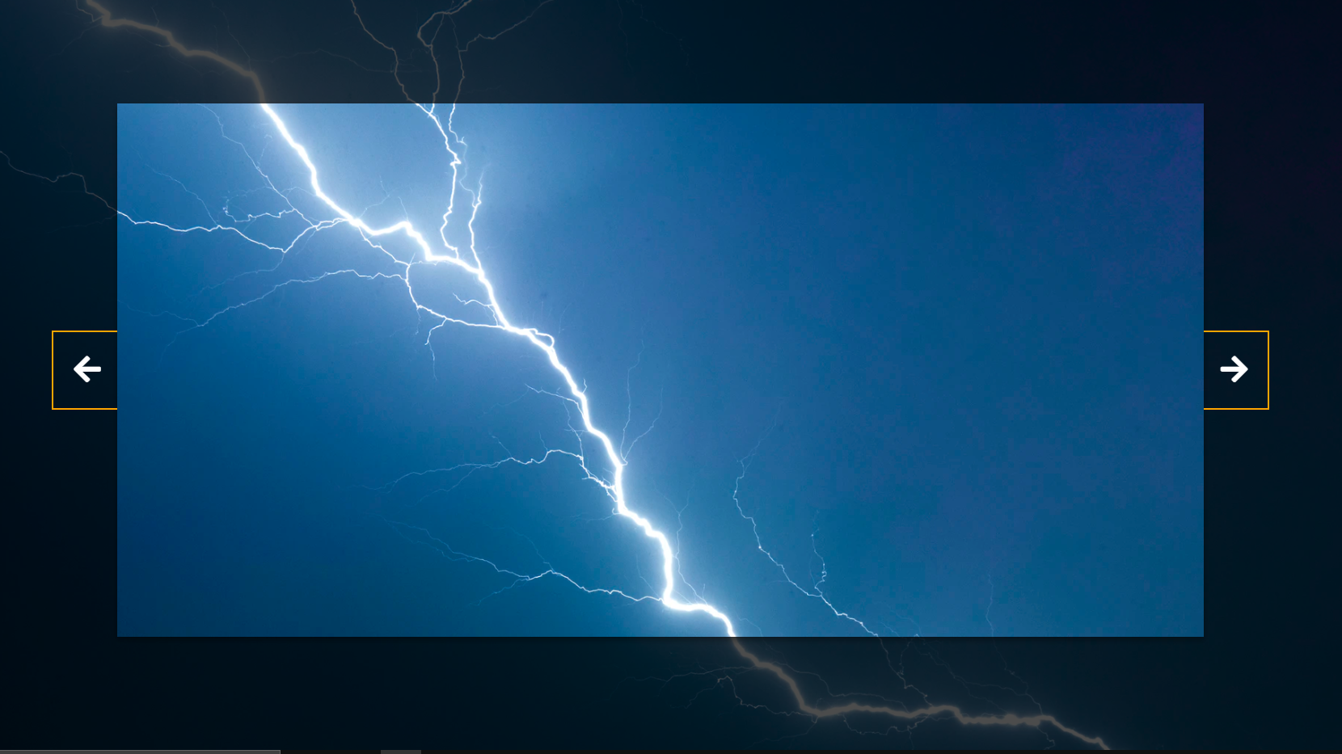

|  |
| --- |
| **PROGRAM #6 03-02-2022** |
| Program to create a Blurry loading App. |

<!DOCTYPE html>

<html lang="en">

<head>

<meta charset="UTF-8" />

<meta name="viewport" content="width=device-width, initial-scale=1.0" />

<link rel="stylesheet" href="style.css" />

<title>Blurry Loading</title>

</head>

<body>

<section class="bg"></section>

<div class="loading-text">0%</div>

<script src="script.js"></script>

</body>

</html>

**JavaScript code-**

const loadText = document.querySelector('.loading-text')

const bg = document.querySelector('.bg')

let load = 0

let int = setInterval(blurring, 30)

function blurring() {

load++

if (load > 99) {

clearInterval(int)

}

loadText.innerText = `${load}%`

loadText.style.opacity = scale(load, 0, 100, 1, 0)

bg.style.filter = `blur(${scale(load, 0, 100, 30, 0)}px)`

}

// https://stackoverflow.com/questions/10756313/javascript-jquery-map-a-range-of-numbers-to-another-range-of-numbers

const scale = (num, in_min, in_max, out_min, out_max) => {

return ((num - in_min) * (out_max - out_min)) / (in_max - in_min) + out_min

}

**CSS code-**

@import url('https://fonts.googleapis.com/css?family=Ubuntu');

* {

box-sizing: border-box;

}

body {

font-family: 'Ubuntu', sans-serif;

display: flex;

align-items: center;

justify-content: center;

height: 100vh;

overflow: hidden;

margin: 0;

}

.bg {

background: url('https://images.unsplash.com/photo-1576161787924-01bb08dad4a4?ixlib=rb-1.2.1&ixid=eyJhcHBfaWQiOjEyMDd9&auto=format&fit=crop&w=2104&q=80')

no-repeat center center/cover;

position: absolute;

top: -30px;

left: -30px;

width: calc(100vw + 60px);

height: calc(100vh + 60px);

z-index: -1;

filter: blur(0px);

}

.loading-text {

font-size: 50px;

color: #fff;

}

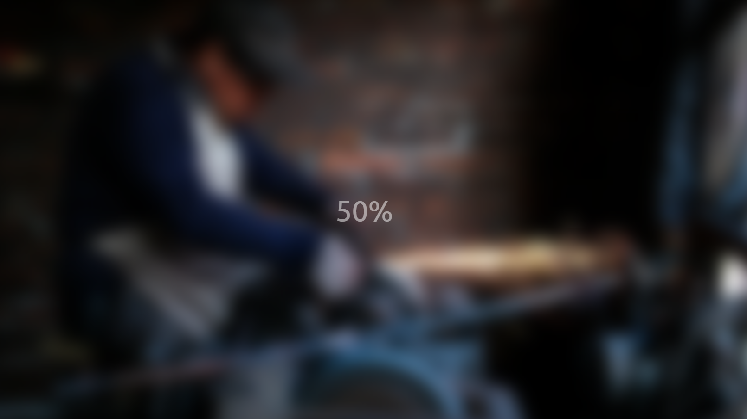

|  |
| --- |
| **PROGRAM #7 03-02-2022** |
| Program to create a Button Ripple Effect. |

<!DOCTYPE html>

<html lang="en">

<head>

<meta charset="UTF-8" />

<meta name="viewport" content="width=device-width, initial-scale=1.0" />

<link rel="stylesheet" href="style.css" />

<title>Button Ripple Effect</title>

</head>

<body>

<button class="ripple">Click Me</button>

<script src="script.js"></script>

</body>

</html>

**JavaScript code-**

const buttons = document.querySelectorAll('.ripple')

buttons.forEach(button => {

button.addEventListener('click', function (e) {

const x = e.clientX

const y = e.clientY

const buttonTop = e.target.offsetTop

const buttonLeft = e.target.offsetLeft

const xInside = x - buttonLeft

const yInside = y - buttonTop

const circle = document.createElement('span')

circle.classList.add('circle')

circle.style.top = yInside + 'px'

circle.style.left = xInside + 'px'

this.appendChild(circle)

setTimeout(() => circle.remove(), 500)

})

})

**CSS code-**

@import url('https://fonts.googleapis.com/css2?family=Roboto:wght@400;700&display=swap');

* {

box-sizing: border-box;

}

body {

background-color: #000;

font-family: 'Roboto', sans-serif;

display: flex;

flex-direction: column;

align-items: center;

justify-content: center;

height: 100vh;

overflow: hidden;

margin: 0;

}

button {

background-color: purple;

color: #fff;

border: 1px purple solid;

font-size: 14px;

text-transform: uppercase;

letter-spacing: 2px;

padding: 20px 30px;

overflow: hidden;

margin: 10px 0;

position: relative;

}

button:focus {

outline: none;

}

button .circle {

position: absolute;

background-color: #fff;

width: 100px;

height: 100px;

border-radius: 50%;

transform: translate(-50%, -50%) scale(0);

animation: scale 0.5s ease-out;

}

@keyframes scale {

to {

transform: translate(-50%, -50%) scale(3);

opacity: 0;

}

}

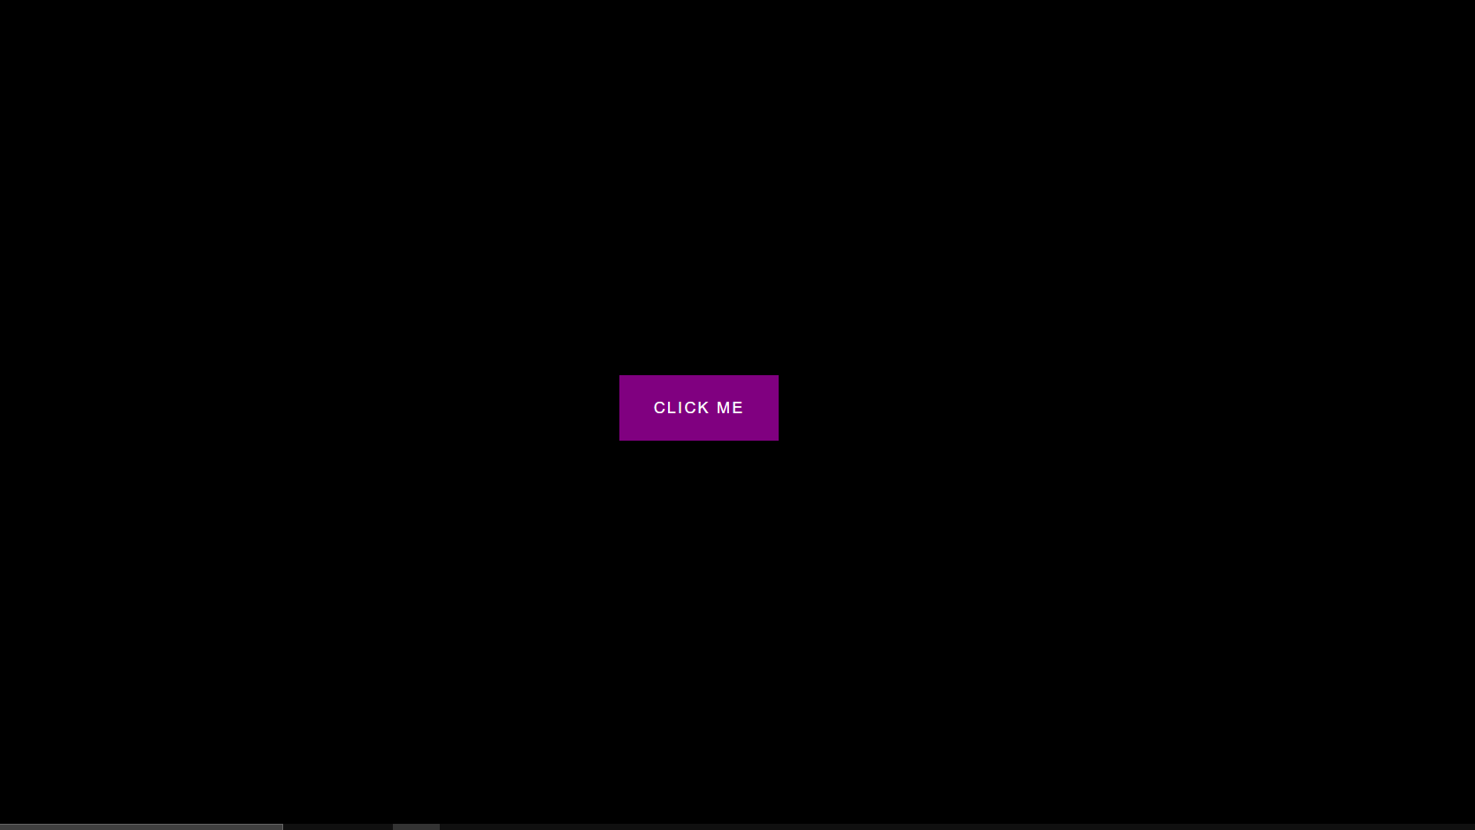

|  |
| --- |
| **PROGRAM #8 03-02-2022** |
| Program to create a Content place holder. |

<!DOCTYPE html>

<html lang="en">

<head>

<meta charset="UTF-8" />

<meta name="viewport" content="width=device-width, initial-scale=1.0" />

<link rel="stylesheet" href="style.css" />

<title>Content Placeholder</title>

</head>

<body>

<div class="card">

<div class="card-header animated-bg" id="header">&nbsp;</div>

<div class="card-content">

<h3 class="card-title animated-bg animated-bg-text" id="title">

&nbsp;

</h3>

<p class="card-excerpt" id="excerpt">

&nbsp;

<span class="animated-bg animated-bg-text">&nbsp;</span>

<span class="animated-bg animated-bg-text">&nbsp;</span>

<span class="animated-bg animated-bg-text">&nbsp;</span>

</p>

<div class="author">

<div class="profile-img animated-bg" id="profile_img">&nbsp;</div>

<div class="author-info">

<strong class="animated-bg animated-bg-text" id="name"

>&nbsp;</strong

>

<small class="animated-bg animated-bg-text" id="date">&nbsp;</small>

</div>

</div>

</div>

</div>

<script src="script.js"></script>

</body>

</html>

**JavaScript code-**

const header = document.getElementById('header')

const title = document.getElementById('title')

const excerpt = document.getElementById('excerpt')

const profile_img = document.getElementById('profile_img')

const name = document.getElementById('name')

const date = document.getElementById('date')

const animated_bgs = document.querySelectorAll('.animated-bg')

const animated_bg_texts = document.querySelectorAll('.animated-bg-text')

setTimeout(getData, 2500)

function getData() {

header.innerHTML =

'<img src="https://images.unsplash.com/photo-1496181133206-80ce9b88a853?ixlib=rb-1.2.1&ixid=eyJhcHBfaWQiOjEyMDd9&auto=format&fit=crop&w=2102&q=80" alt="" />'

title.innerHTML = 'Lorem ipsum dolor sit amet'

excerpt.innerHTML =

'Lorem ipsum dolor sit amet consectetur adipisicing elit. Dolore perferendis'

profile_img.innerHTML =

'<img src="https://randomuser.me/api/portraits/men/45.jpg" alt="" />'

name.innerHTML = 'John Doe'

date.innerHTML = 'Oct 08, 2020'

animated_bgs.forEach((bg) => bg.classList.remove('animated-bg'))

animated_bg_texts.forEach((bg) => bg.classList.remove('animated-bg-text'))

}

**CSS code-**

@import url('https://fonts.googleapis.com/css2?family=Roboto:wght@400;700&display=swap');

* {

box-sizing: border-box;

}

body {

background-color: #ecf0f1;

font-family: 'Roboto', sans-serif;

display: flex;

align-items: center;

justify-content: center;

height: 100vh;

overflow: hidden;

margin: 0;

}

img {

max-width: 100%;

}

.card {

box-shadow: 0 2px 10px rgba(0, 0, 0, 0.2);

border-radius: 10px;

overflow: hidden;

width: 350px;

}

.card-header {

height: 200px;

}

.card-header img {

object-fit: cover;

height: 100%;

width: 100%;

}

.card-content {

background-color: #fff;

padding: 30px;

}

.card-title {

height: 20px;

margin: 0;

}

.card-excerpt {

color: #777;

margin: 10px 0 20px;

}

.author {

display: flex;

}

.profile-img {

border-radius: 50%;

overflow: hidden;

height: 40px;

width: 40px;

}

.author-info {

display: flex;

flex-direction: column;

justify-content: space-around;

margin-left: 10px;

width: 100px;

}

.author-info small {

color: #aaa;

margin-top: 5px;

}

.animated-bg {

background-image: linear-gradient(

to right,

#f6f7f8 0%,

#edeef1 10%,

#f6f7f8 20%,

#f6f7f8 100%

);

background-size: 200% 100%;

animation: bgPos 1s linear infinite;

}

.animated-bg-text {

border-radius: 50px;

display: inline-block;

margin: 0;

height: 10px;

width: 100%;

}

@keyframes bgPos {

0% {

background-position: 50% 0;

}

100% {

background-position: -150% 0;

}

}

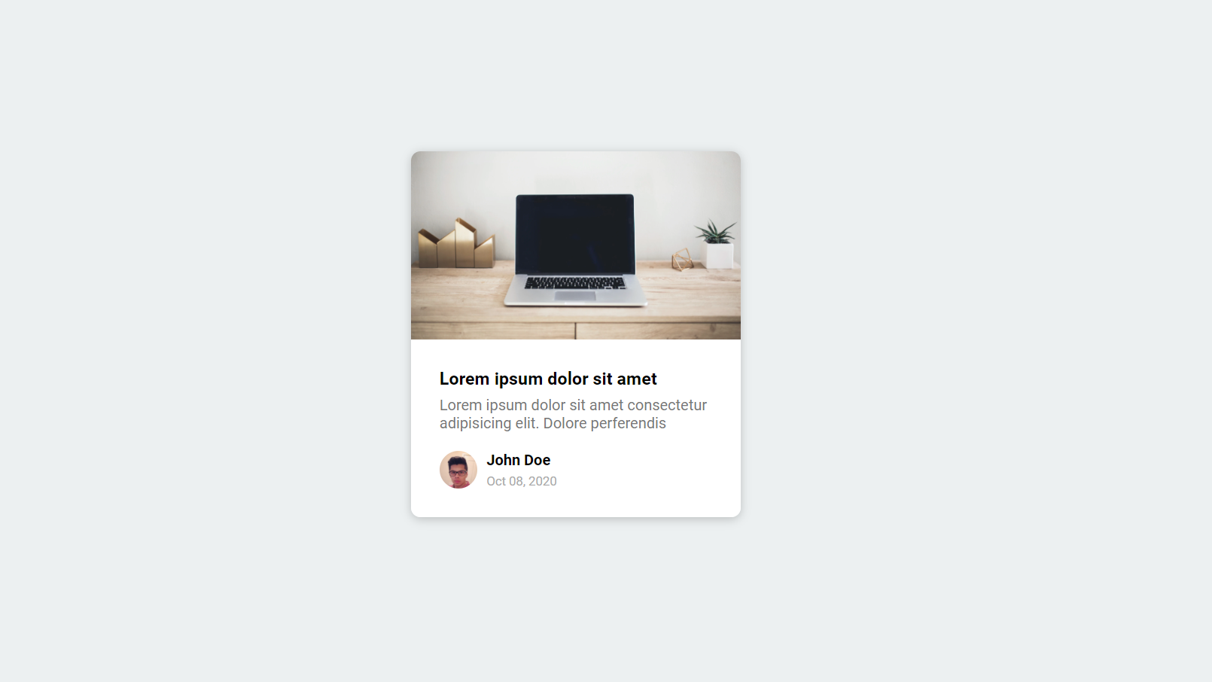

|  |
| --- |
| **PROGRAM #9 03-02-2022** |
| Program to create a Custom-Range slider. |

<!DOCTYPE html>

<html lang="en">

<head>

<meta charset="UTF-8" />

<meta name="viewport" content="width=device-width, initial-scale=1.0" />

<link rel="stylesheet" href="style.css" />

<title>Custom Range Slider</title>

</head>

<body>

<h2>Custom Range Slider</h2>

<div class="range-container">

<input type="range" id="range" min="0" max="100">

<label for="range">50</label>

</div>

<script src="script.js"></script>

</body>

</html>

**JavaScript code-**

const range = document.getElementById('range')

range.addEventListener('input', (e) => {

const value = +e.target.value

const label = e.target.nextElementSibling

const range_width = getComputedStyle(e.target).getPropertyValue('width')

const label_width = getComputedStyle(label).getPropertyValue('width')

const num_width = +range_width.substring(0, range_width.length - 2)

const num_label_width = +label_width.substring(0, label_width.length - 2)

const max = +e.target.max

const min = +e.target.min

const left = value * (num_width / max) - num_label_width / 2 + scale(value, min, max, 10, -10)

label.style.left = `${left}px`

label.innerHTML = value

})

// https://stackoverflow.com/questions/10756313/javascript-jquery-map-a-range-of-numbers-to-another-range-of-numbers

const scale = (num, in_min, in_max, out_min, out_max) => {

return (num - in_min) * (out_max - out_min) / (in_max - in_min) + out_min;

}

**CSS code-**

@import url('https://fonts.googleapis.com/css?family=Lato&display=swap');

* {

box-sizing: border-box;

}

body {

background-image: linear-gradient(135deg, #f5f7fa 0%, #c3cfe2 100%);

font-family: 'Lato', sans-serif;

display: flex;

flex-direction: column;

align-items: center;

justify-content: center;

height: 100vh;

overflow: hidden;

margin: 0;

}

h2 {

position: absolute;

top: 10px;

}

.range-container {

position: relative;

}

input[type='range'] {

width: 300px;

margin: 18px 0;

-webkit-appearance: none;

}

input[type='range']:focus {

outline: none;

}

input[type='range'] + label {

background-color: #fff;

position: absolute;

top: -25px;

left: 110px;

width: 80px;

padding: 5px 0;

text-align: center;

border-radius: 4px;

box-shadow: 0 0 5px rgba(0, 0, 0, 0.3);

}

/* Chrome & Safari */

input[type='range']::-webkit-slider-runnable-track {

background: purple;

border-radius: 4px;

width: 100%;

height: 10px;

cursor: pointer;

}

input[type='range']::-webkit-slider-thumb {

-webkit-appearance: none;

height: 24px;

width: 24px;

background: #fff;

border-radius: 50%;

border: 1px solid purple;

margin-top: -7px;

cursor: pointer;

}

/* Firefox */

input[type='range']::-moz-range-track {

background: purple;

border-radius: 4px;

width: 100%;

height: 13px;

cursor: pointer;

}

input[type='range']::-moz-range-thumb {

-webkit-appearance: none;

height: 24px;

width: 24px;

background: #fff;

border-radius: 50%;

border: 1px solid purple;

margin-top: -7px;

cursor: pointer;

}

/* IE */

input[type='range']::-ms-track {

background: purple;

border-radius: 4px;

width: 100%;

height: 13px;

cursor: pointer;

}

input[type='range']::-ms-thumb {

-webkit-appearance: none;

height: 24px;

width: 24px;

background: #fff;

border-radius: 50%;

border: 1px solid purple;

margin-top: -7px;

cursor: pointer;

}

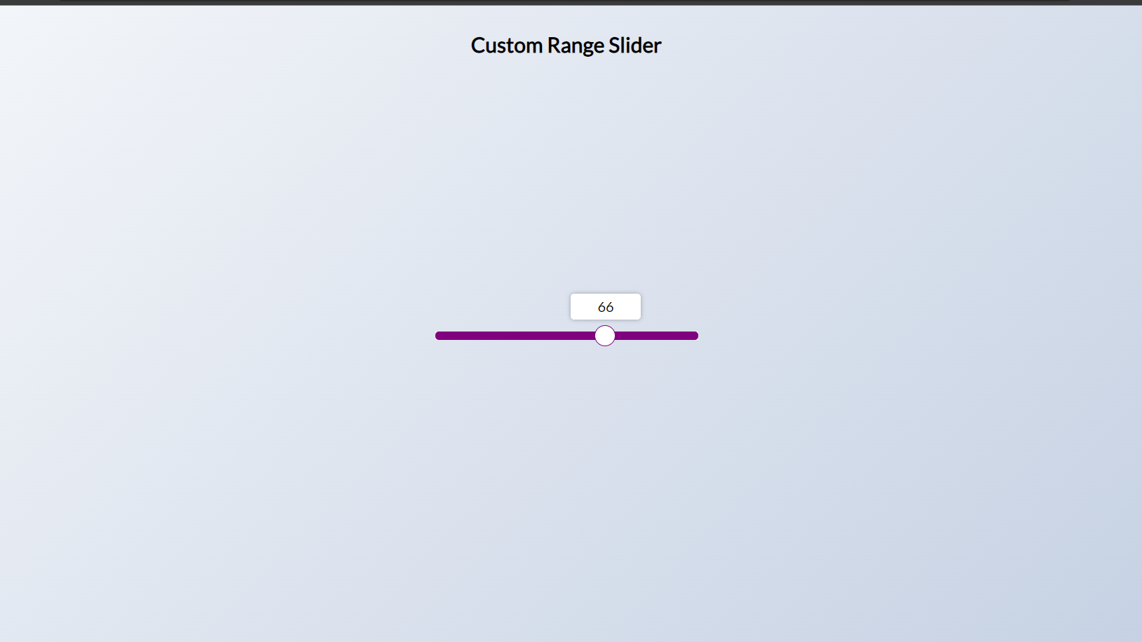

|  |
| --- |
| **PROGRAM #10 03-02-2022** |
| Program to create a Project Starter. |

<!DOCTYPE html>

<html lang="en">

<head>

<meta charset="UTF-8" />

<meta name="viewport" content="width=device-width, initial-scale=1.0" />

<link rel="stylesheet" href="style.css" />

<title>My Project</title>

</head>

<body>

<h1>Project Starter</h1>

<script src="script.js"></script>

</body>

</html>

**CSS code-**

@import url('https://fonts.googleapis.com/css2?family=Roboto:wght@400;700&display=swap');

* {

box-sizing: border-box;

}

body {

font-family: 'Roboto', sans-serif;

display: flex;

flex-direction: column;

align-items: center;

justify-content: center;

height: 100vh;

overflow: hidden;

margin: 0;

}

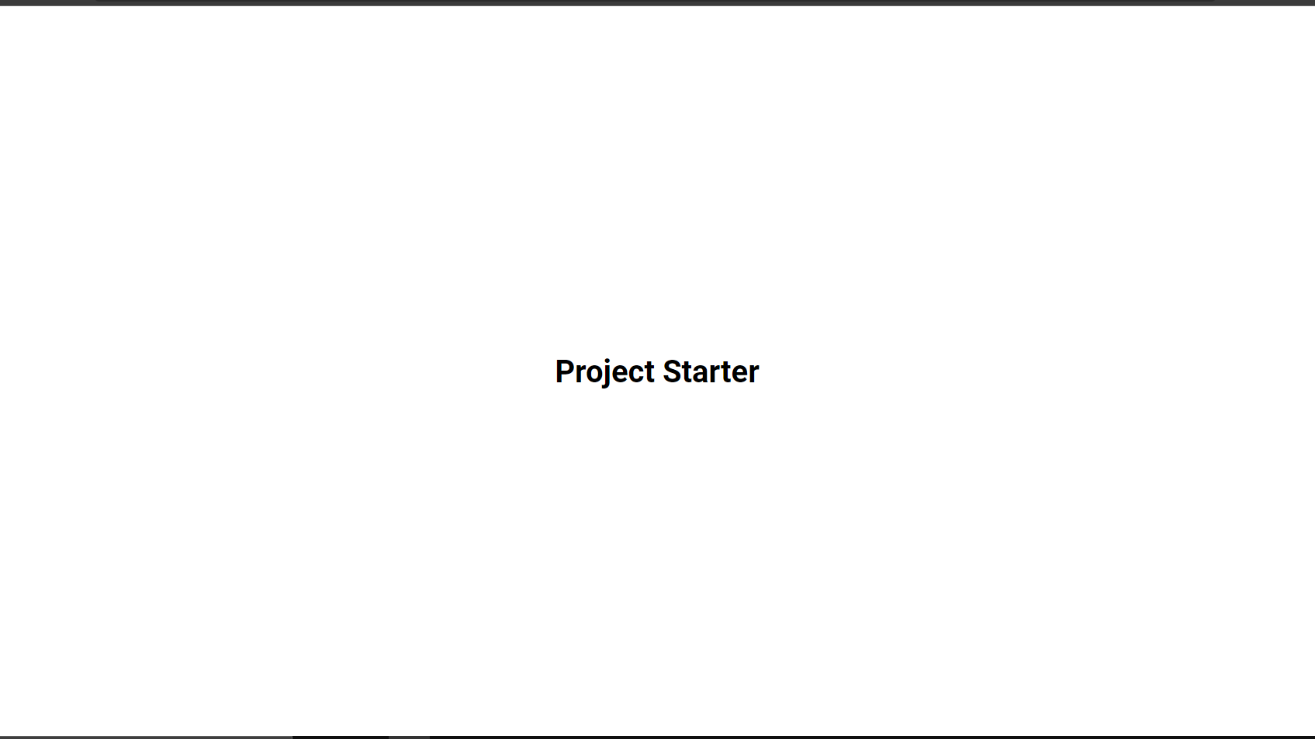

|  |
| --- |
| **PROGRAM #11 03-02-2022** |
| XML Program to create a user registration page. |

<?xml version="1.0" encoding="utf-8"?>  
<LinearLayout xmlns:android="http://schemas.android.com/apk/res/android"  
 xmlns:app="http://schemas.android.com/apk/res-auto"  
 xmlns:tools="http://schemas.android.com/tools"  
 android:layout_width="match_parent"  
 android:layout_height="match_parent"  
 android:orientation="vertical"  
 tools:context=".User.UserRegistration">  
  
 <ScrollView  
 android:layout_width="match_parent"  
 android:layout_height="match_parent">  
  
 <LinearLayout  
 android:layout_width="match_parent"  
 android:layout_height="match_parent"  
 android:layout_margin="25dp"  
 android:gravity="center_vertical"  
 android:orientation="vertical">  
  
 <EditText  
 android:background="@drawable/custom_edittext"  
 android:textColorHint="@color/app_text"  
 android:paddingLeft="10dp"  
 android:id="@+id/user_reg_name"  
 android:layout_width="match_parent"  
 android:layout_marginTop="10dp"  
 android:fontFamily="serif-monospace"  
 android:hint="Name"  
 android:gravity="center"  
 android:layout_height="50dp"/>  
  
  
 <RadioGroup  
 android:gravity="center"  
 android:id="@+id/user_reg_rdgroup"  
 android:layout_width="match_parent"  
 android:layout_height="wrap_content"  
 android:layout_marginTop="10dp"  
 android:orientation="horizontal">  
  
 <TextView  
 android:layout_width="wrap_content"  
 android:layout_height="wrap_content"  
 android:fontFamily="serif-monospace"  
 android:paddingLeft="2dp"  
 android:textSize="17dp"  
 android:paddingRight="15dp"  
 android:text="Gender" />  
  
 <RadioButton  
 android:id="@+id/user_reg_male"  
 android:layout_width="wrap_content"  
 android:layout_height="wrap_content"  
 android:checked="true"  
 android:textSize="16dp"  
 android:fontFamily="serif-monospace"  
 android:paddingRight="5dp"  
 android:text="Male" />  
  
 <RadioButton  
 android:id="@+id/user_reg_female"  
 android:textSize="16dp"  
 android:layout_width="wrap_content"  
 android:layout_height="wrap_content"  
 android:fontFamily="serif-monospace"  
 android:text="Female" />  
 </RadioGroup>  
 <EditText  
 android:background="@drawable/custom_edittext"  
 android:textColorHint="@color/app_text"  
 android:gravity="center"  
 android:paddingLeft="10dp"  
 android:id="@+id/user_reg_address"  
 android:layout_width="match_parent"  
 android:layout_marginTop="10dp"  
 android:fontFamily="serif-monospace"  
 android:hint="Aadhaar"  
 android:inputType="number"  
 android:layout_height="50dp"/>  
 <EditText  
 android:background="@drawable/custom_edittext"  
 android:textColorHint="@color/app_text"  
 android:gravity="center"  
 android:paddingLeft="10dp"  
 android:id="@+id/user_reg_phone"  
 android:layout_width="match_parent"  
 android:layout_marginTop="10dp"  
 android:fontFamily="serif-monospace"  
 android:hint="Phone"  
 android:maxLength="10"  
 android:inputType="number"  
 android:layout_height="50dp"/>  
 <EditText  
 android:background="@drawable/custom_edittext"  
 android:textColorHint="@color/app_text"  
 android:gravity="center"  
 android:paddingLeft="10dp"  
 android:id="@+id/user_reg_email"  
 android:layout_width="match_parent"  
 android:layout_marginTop="10dp"  
 android:fontFamily="serif-monospace"  
 android:hint="Email"  
 android:inputType="textEmailAddress"  
 android:layout_height="50dp"/>  
  
 <EditText  
 android:background="@drawable/custom_edittext"  
 android:textColorHint="@color/app_text"  
 android:gravity="center"  
 android:paddingLeft="10dp"  
 android:id="@+id/user_reg_password"  
 android:layout_width="match_parent"  
 android:layout_marginTop="10dp"  
 android:fontFamily="serif-monospace"  
 android:hint="Password"  
 android:inputType="textPassword"  
 android:layout_height="50dp"/>  
 <EditText  
 android:background="@drawable/custom_edittext"  
 android:textColorHint="@color/app_text"  
 android:gravity="center"  
 android:paddingLeft="10dp"  
 android:id="@+id/user_reg_repassword"  
 android:layout_width="match_parent"  
 android:layout_marginTop="10dp"  
 android:fontFamily="serif-monospace"  
 android:hint="Re Password"  
 android:inputType="textPassword"  
 android:layout_height="50dp"/>  
  
  
  
 <Button  
 android:background="@drawable/custom_button"  
 android:id="@+id/user_reg_btnreg"  
 android:layout_width="match_parent"  
 android:layout_height="50dp"  
 android:layout_gravity="center_vertical|center_horizontal"  
 android:layout_marginTop="25dp"  
 android:layout_marginBottom="10dp"  
 android:fontFamily="serif-monospace"  
 android:text=" SignUp "  
 android:textColor="@color/colorPrimaryDark"  
 android:textSize="20dp"  
 android:textStyle="bold" />  
  
 <TextView  
 android:id="@+id/user_reg_login"  
 android:layout_width="match_parent"  
 android:layout_height="wrap_content"  
 android:layout_marginTop="20dp"  
 android:layout_marginBottom="10dp"  
 android:fontFamily="sans-serif"  
 android:gravity="center_horizontal"  
 android:text="login me"  
 android:textSize="17dp"  
 android:textColor="@color/colorPrimaryDark"  
 android:textStyle="bold" />  
  
  
 </LinearLayout>  
  
 </ScrollView>  
  
</LinearLayout>

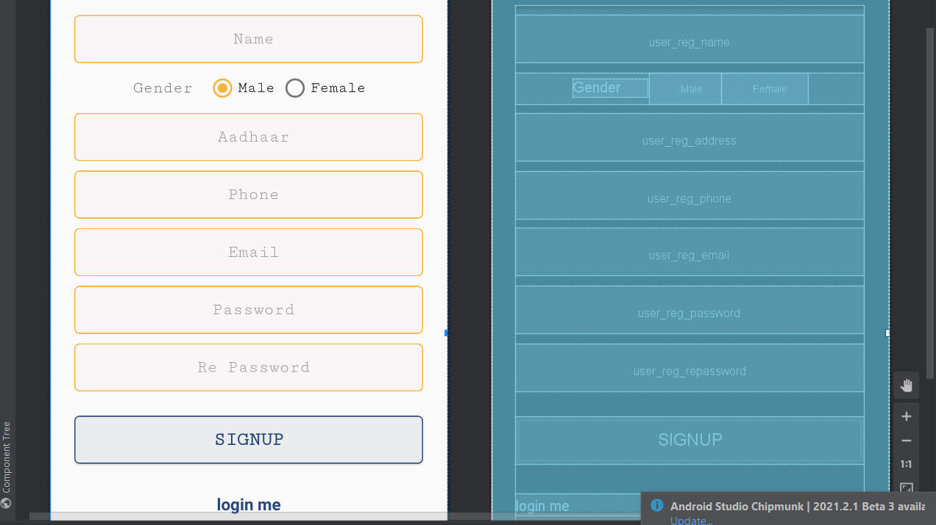

|  |
| --- |
| **PROGRAM #12 03-02-2022** |
| XML program to print details of a breakfast menu. |

<description>Two of our famous Belgian Waffles with plenty of real maple

syrup</description>

<calories>650</calories>

</food>

<food>

<name>Strawberry Belgian Waffles</name>

<price>$7.95</price>

<description>Light Belgian waffles covered with strawberries and whipped

cream</description>

<calories>900</calories>

</food>

<food>

<name>Berry-Berry Belgian Waffles</name>

<price>$8.95</price>

<description>Light Belgian waffles covered with an assortment of fresh berries and whipped

cream</description>

<calories>900</calories>

</food>

<food>

<name>French Toast</name>

<price>$4.50</price>

<description>Thick slices made from our homemade sourdough bread</description>

<calories>600</calories>

</food>

<food>

<name>Homestyle Breakfast</name>

<price>$6.95</price>

<description>Two eggs, bacon or sausage, toast, and our ever-popular hash

browns</description>

<calories>950</calories>

</food>

</breakfast_menu>

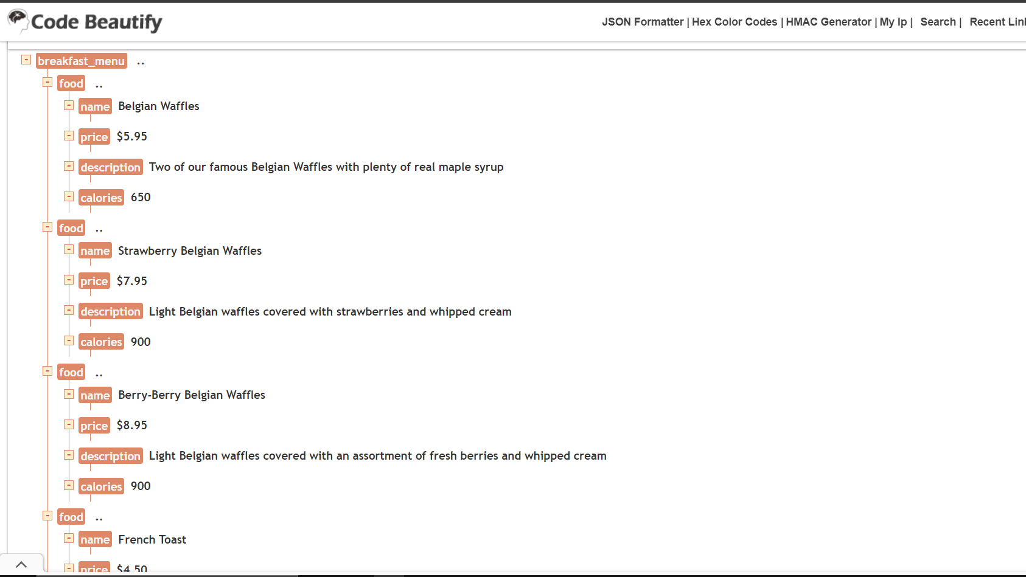

|  |
| --- |
| **PROGRAM #13 03-02-2022** |
| XML program to print details of a books. |

<bookstore>

<book category="COOKING">

<title lang="en">Everyday Italian</title>

<author>Giada De Laurentiis</author>

<year>2005</year>

<price>30.00</price>

</book>

<book category="CHILDREN">

<title lang="en">Harry Potter</title>

<author>J K. Rowling</author>

<year>2005</year>

<price>29.99</price>

</book>

<book category="WEB">

<title lang="en">Learning XML</title>

<author>Erik T. Ray</author>

<year>2003</year>

<price>39.95</price>

</book>

</bookstore>

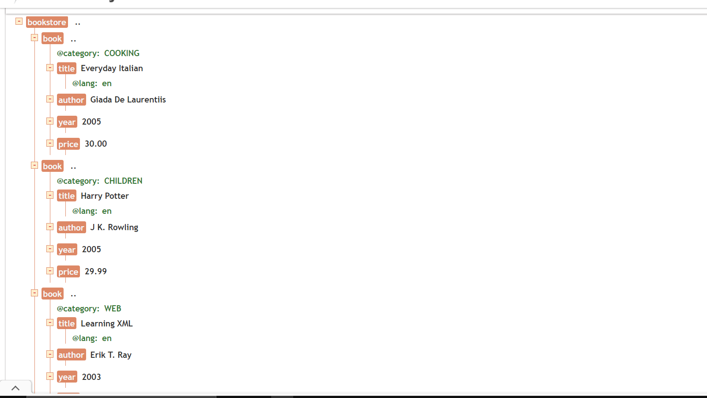

|  |
| --- |
| **PROGRAM #14 03-02-2022** |
| AJAX Program to retrieve data from a Txt. |

<!DOCTYPE html>

<html>

<body>

<div id="demo">

<h2>The XMLHttpRequest Object</h2>

<button type="button" onclick="loadDoc()">Change Content</button>

</div>

<script>

function loadDoc() {

const xhttp = new XMLHttpRequest();

xhttp.onload = function() {

document.getElementById("demo").innerHTML =

this.responseText;

}

xhttp.open("GET", "ajax_info.txt");

xhttp.send();

}

</script>

</body>

</html>

/*AJAX TXT*/

AJAX

AJAX is not a programming language.

AJAX is a technique for accessing web servers from a web page.

AJAX stands for Asynchronous JavaScript And XML.

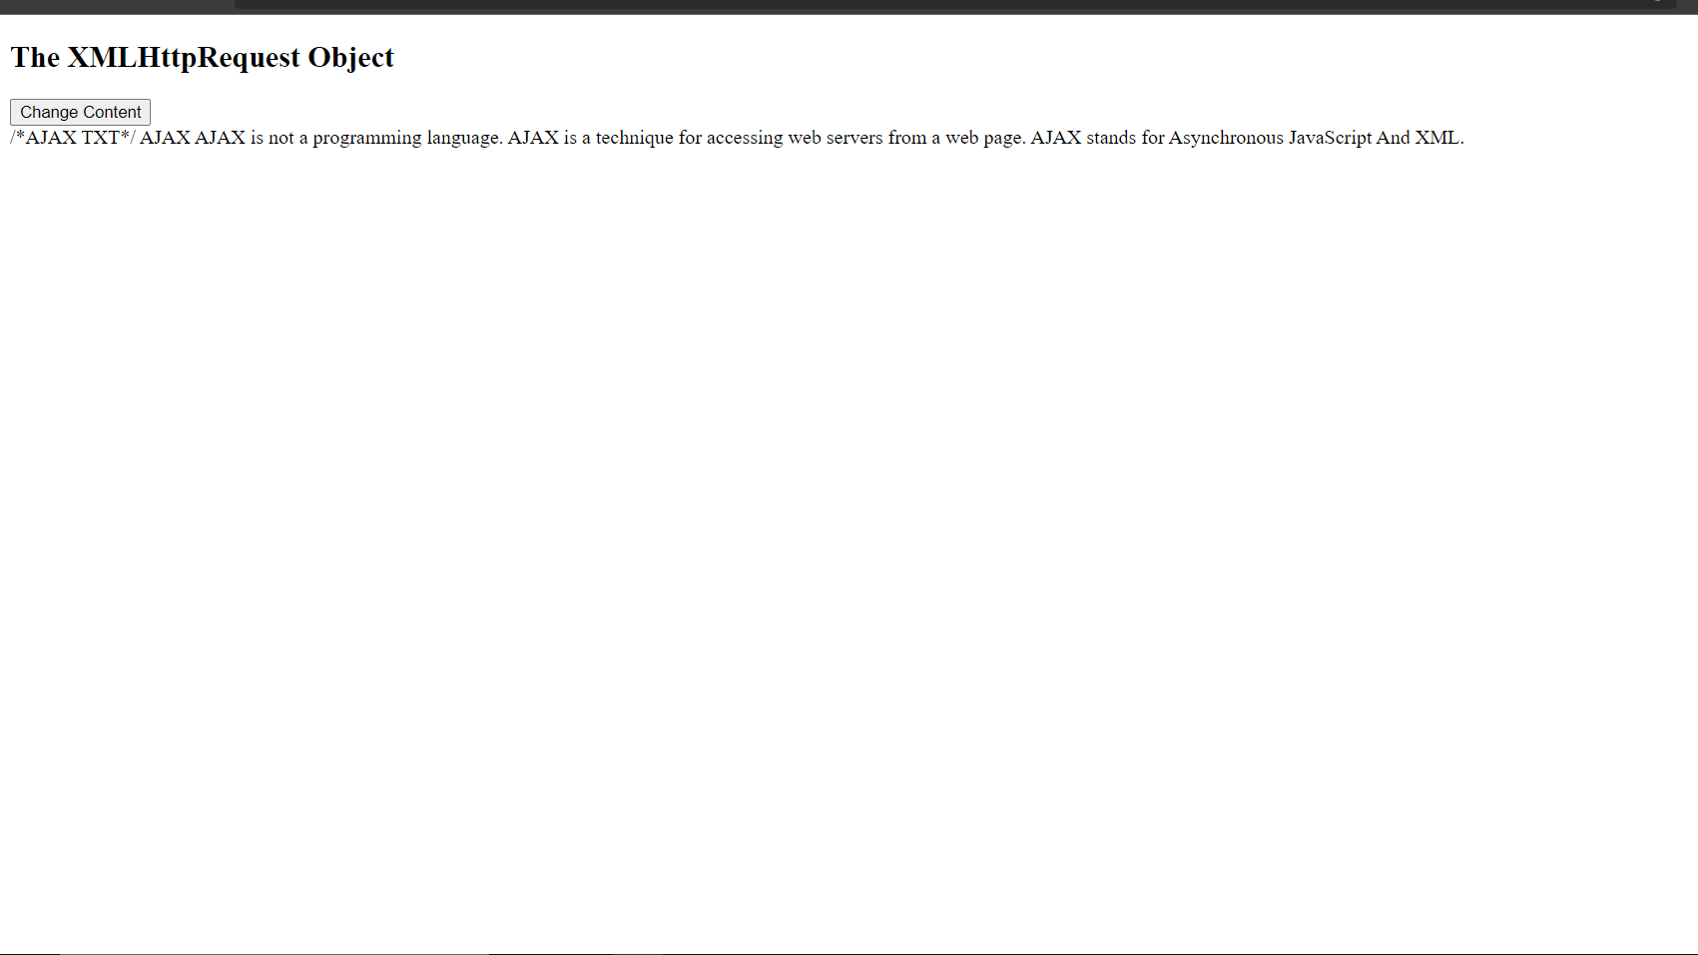

|  |
| --- |
| **PROGRAM #15 03-02-2022** |
| AJAX Program to retrieve all header information of a file. |

<!DOCTYPE html>

<html>

<body>

<h2>The XMLHttpRequest Object</h2>

<p>The getAllResponseHeaders() function returns all the header information of a resource, like

length, server-type, content-type, last-modified, etc:</p>

<p id="demo"></p>

<script>

const xhttp = new XMLHttpRequest();

xhttp.onload = function() {

document.getElementById("demo").innerHTML =

this.getAllResponseHeaders();

}

xhttp.open("GET", "ajax_info.txt");

xhttp.send();

</script>

</body>

</html>

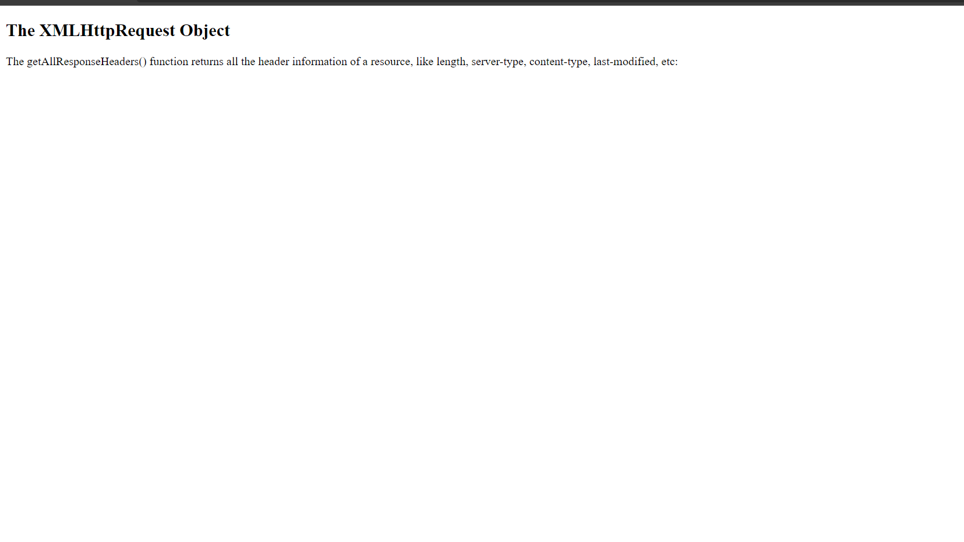

|  |
| --- |
| **PROGRAM #16 03-02-2022** |
| AJAX Program to retrieve all specific information of a file. |

<!DOCTYPE html>

<html>

<body>

<h2>The XMLHttpRequest Object</h2>

<p>The getAllResponseHeaders() function returns all the header information of a resource, like

length, server-type, content-type, last-modified, etc:</p>

<p id="demo"></p>

<script>

const xhttp = new XMLHttpRequest();

xhttp.onload = function() {

document.getElementById("demo").innerHTML =

this.getAllResponseHeaders();

}

xhttp.open("GET", "ajax_info.txt");

xhttp.send();

</script>

</body>

</html>

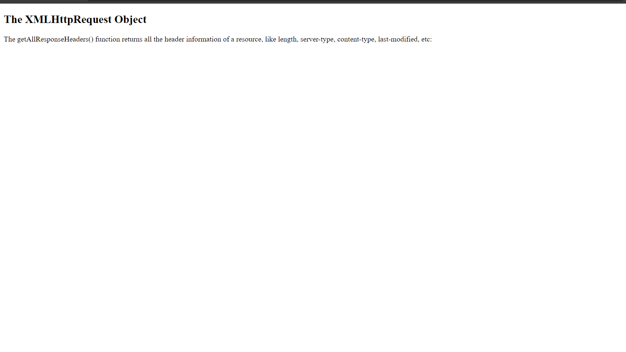

|  |
| --- |
| **PROGRAM #17 03-02-2022**  Reversing a string using php code. |

<?php

$string = "HTML";

echo "Reverse string of $string is " .strrev ( $string );

?>

|  |
| --- |
| **PROGRAM #18 03-02-2022** |
| Swapping two numbers. |

<?php

$a = 45;

$b = 78;

// Swapping Logic

$third = $a;

$a = $b;

$b = $third;

echo "After swapping:<br><br>";

echo "a =".$a." b=".$b;

?>

|  |
| --- |
| **PROGRAM #19 03-02-2022** |
| Finding the Area of a rectangle using PHP. |

<html>

<body>

<form method = "post">

Width: <input type="number" name="width">

<br><br>

Length: <input type="number" name="length"> <br>

<input type = "submit" name = "submit" value="Calculate">

</form>

</body>

</html>

<?php

if(isset($_POST['submit']))

{

$width = $_POST['width'];

$length = $_POST['length'];

$area = $width*$length;

echo "The area of a rectangle with $width x $length is $area";

}

?>

Screenshot:

|  |
| --- |
| **PROGRAM #20 03-02-2022** |
| Displaying the current date . |

<?php

echo "The date and time is :";

$myDate = date("d-m-y h:i:s");

echo $myDate;

?>

|  |
| --- |
| **PROGRAM #21 03-02-2022** |
| Implementing palindrome using php . |

<?php

function palindrome($n){

$number = $n;

$sum = 0;

while(floor($number)) {

$rem = $number % 10;

$sum = $sum * 10 + $rem;

$number = $number/10;

}

return $sum;

}

$input = 1235321;

$num = palindrome($input);

if($input==$num){

echo "$input is a Palindrome number";

} else {

echo "$input is not a Palindrome";

}

?>

|  |
| --- |
| **PROGRAM #22 03-02-2022** |
| Extracting number from string . |

<?php

$string = '$ 9000';

echo "The extracted numbers from string are :";

echo "\n<br/>";

echo preg_replace("/[^0-9]/", '', $string);

echo "\n<br/>";

$string2 = '$ 7898';

echo preg_replace("/[^0-9\.]/", '', $string2);

echo "\n<br/>";

$string3 = 'Mike has 10 red and 23 blue balls';

echo preg_replace("/[^0-9]/", '', $string3);

echo "\n";

?>

|  |
| --- |
| **PROGRAM #23 03-02-2022** |
| Implementing Exception handling . |

<?php

$filename = "palin.php";

if (file_exists($filename)) {

echo "File exist.";

} else {

echo "File does not exist.";

}

?>

|  |
| --- |
| **PROGRAM #24 03-02-2022** |
| Create a form using PHP. |

<?php

$nameErr = $emailErr = $genderErr = $websiteErr = "";

$name = $email = $gender = $comment = $website = "";

if ($_SERVER["REQUEST_METHOD"] == "POST") {

if (empty($_POST["name"])) {

$nameErr = "Name is required";

} else {

$name = test_input($_POST["name"]);

if (!preg_match("/^[a-zA-Z-' ]*$/",$name)) {

$nameErr = "Only letters and white space allowed";

}

}

if (empty($_POST["email"])) {

$emailErr = "Email is required";

} else {

$email = test_input($_POST["email"]);

if (!filter_var($email, FILTER_VALIDATE_EMAIL)) {

$emailErr = "Invalid email format";

}

}

if (empty($_POST["website"])) {

$website = "";

} else {

$website = test_input($_POST["website"]);

if (!preg_match("/\b(?:(?:https?|ftp):\/\/|www\.)[-a-z0-9+&@#\/%?=~_|!:,.;]*[-a-z0-

9+&@#\/%=~_|]/i",$website)) {

$websiteErr = "Invalid URL";

}

}

if (empty($_POST["comment"])) {

$comment = "";

} else {

$comment = test_input($_POST["comment"]);

}

if (empty($_POST["gender"])) {

$genderErr = "Gender is required";

} else {

$gender = test_input($_POST["gender"]);

}

}

function test_input($data) {

$data = trim($data);

$data = stripslashes($data);

$data = htmlspecialchars($data);

return $data;

}

?>

<h2>PHP Form </h2>

<p><span class="error">* required field</span></p>

<form method="post" action="<?php echo htmlspecialchars($_SERVER["PHP_SELF"]);?>">

Name: <input type="text" name="name" value="<?php echo $name;?>">

<span class="error">* <?php echo $nameErr;?></span>

<br><br>

E-mail: <input type="text" name="email" value="<?php echo $email;?>">

<span class="error">* <?php echo $emailErr;?></span>

<br><br>

Website: <input type="text" name="website" value="<?php echo $website;?>">

<span class="error"><?php echo $websiteErr;?></span>

<br><br>

Comment: <textarea name="comment" rows="5" cols="40"><?php echo

$comment;?></textarea>

<br><br>

Gender:

<input type="radio" name="gender" <?php if (isset($gender) && $gender=="female") echo

"checked";?> value="female">Female

<input type="radio" name="gender" <?php if (isset($gender) && $gender=="male") echo

"checked";?> value="male">Male

<input type="radio" name="gender" <?php if (isset($gender) && $gender=="other") echo

"checked";?> value="other">Other

<span class="error">* <?php echo $genderErr;?></span>

<br><br>

<input type="submit" name="submit" value="Submit">

</form>

<?php

echo "<h2>Your Input:</h2>";

echo $name;

echo "<br>";

echo $email;

echo "<br>";

echo $website;

echo "<br>";

echo $comment;

echo "<br>";

echo $gender;

?>

|  |
| --- |
| **PROGRAM #25 03-02-2022** |
| Check whether the number is prime or not. |

<!DOCTYPE html>

<html><body>

<?php

$num = 13;

$count=0;

for ( $i=1; $i<=$num; $i++)

{

if (($num%$i)==0)

{

$count++;

}

}

if ($count<3)

{

echo "$num is a prime number.";

}

else

{

echo "$num is not a prime number.";

}?></body></html>

|  |
| --- |
| **PROGRAM #26 03-02-2022** |
| Multiples of seven implemented using PHP. |

<?php

define('a', 7);

for($i=1; $i<=10; $i++)

{

echo $i*a;

echo '<br>';

}

?>

|  |
| --- |
| **PROGRAM #27 03-02-2022** |
| Program to display email details using JSON. |

{"employees":[

{"name":"Umesh", "email":"umesh@gmail.com"},

{"name":"vinesh", "email":"vinesh@gmail.com"},

{"name":"vishnu", "email":"vishnu@gmail.com"}

]}

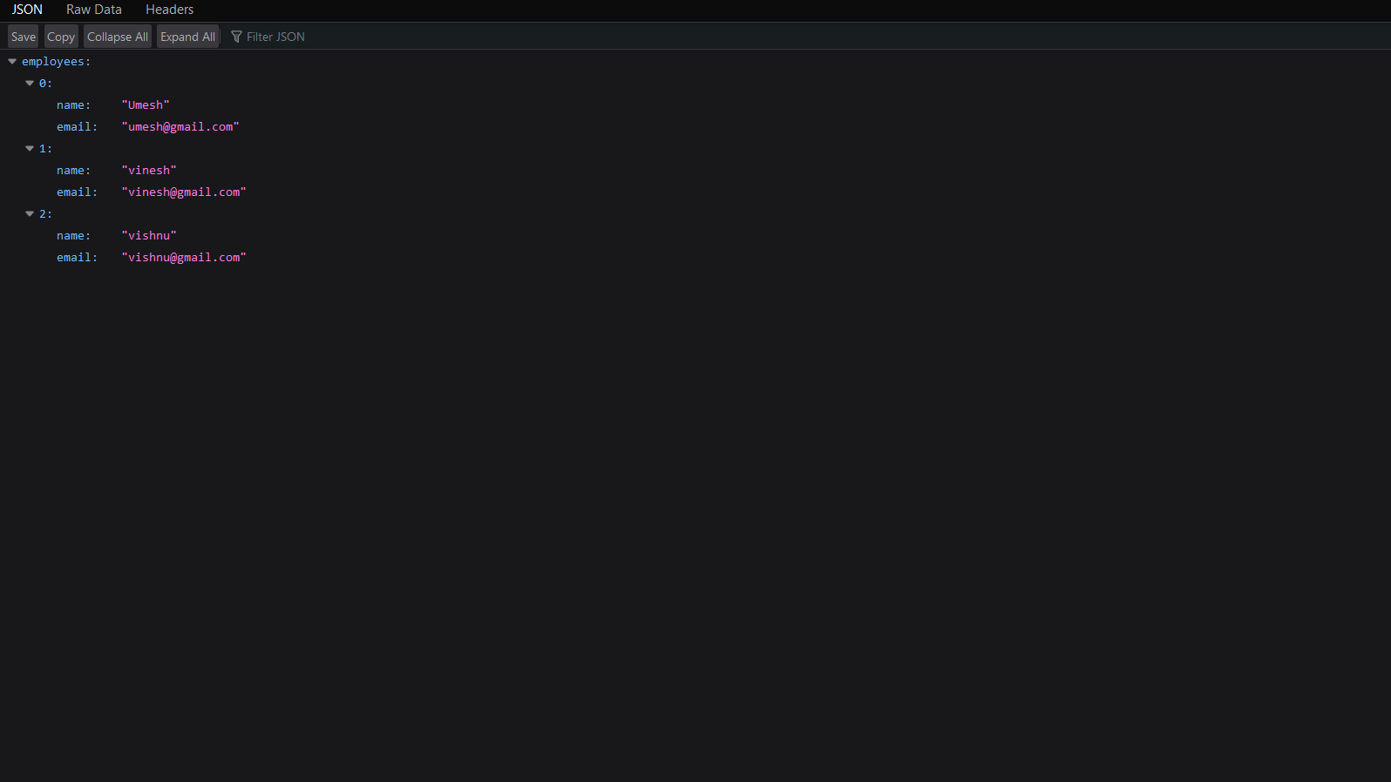

|  |
| --- |
| **PROGRAM #28 03-02-2022** |
| Program to display break fast menu using JSON. |

{

"breakfast_menu": {

"food": [

{

"name": "Belgian Waffles",

"price": "$5.95",

"description": "Two of our famous Belgian Waffles with plenty of real maple syrup",

"calories": 650

},

{

"name": "Strawberry Belgian Waffles",

"price": "$7.95",

"description": "Light Belgian waffles covered with strawberries and whipped cream",

"calories": 900

},

{

"name": "Berry-Berry Belgian Waffles",

"price": "$8.95",

"description": "Light Belgian waffles covered with an assortment of fresh berries and

whipped cream",

"calories": 900

},

{

"name": "French Toast",

"price": "$4.50",

"description": "Thick slices made from our homemade sourdough bread",

"calories": 600

},

{

"name": "Homestyle Breakfast",

"price": "$6.95",

"description": "Two eggs, bacon or sausage, toast, and our ever-popular hash browns",

"calories": 950

}

]

}

}

|  |
| --- |
| **PROGRAM #29 03-02-2022** |
| Program to display details of books using JSON. |

{

"bookstore": {

"book": [

{

"title": "Everyday Italian",

"author": "Giada De Laurentiis",

"year": 2005,

"price": 30

},

{

"title": "Harry Potter",

"author": "J K. Rowling",

"year": 2005,

"price": 29.99

},

{

"title": "Learning XML",

"author": "Erik T. Ray",

"year": 2003,

"price": 39.95

}

]

}}

